Assignment 13.2
Laxmi Spandana
2303A52094
Batch 40
Task Description -1 (Refactoring – Eliminating Repetitive Logic) • Task: Use AI-assisted coding techniques to restructure a Python program that performs repeated calculations, transforming it into a reusable and maintainable design.
Instructions:
- Ask AI to locate repeated computations within the program.
- Encapsulate repeated logic into reusable functions.
- Verify that program output remains unchanged after refactoring.
- Add proper docstrings to all defined functions.
Sample Code:
length = 8 width = 4 print("Area:", length * width) print("Perimeter:", 2 * (length + width)) length = 12 width = 6 print("Area:", length * width) print("Perimeter:", 2 * (length + width))
Expected Output:
A refactored Python script that uses a single reusable function to compute area and perimeter without repeating code.

Prompt and Code
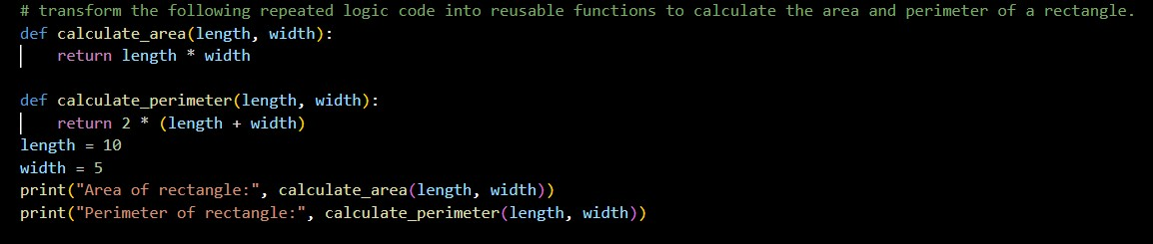
Task Description -2 (Refactoring – Modularizing Inline
Calculations)
- Task: Use AI to refactor a Python script by extracting repeated inline calculations into reusable and well-documented functions.
Instructions:
- Identify repeated calculation patterns in the code.
- Convert them into reusable functions.
- Ensure readability and proper documentation.
Sample Code: amount = 1000 discount = amount * 0.10 final_amount = amount - discount print("Final Amount:", final_amount) amount = 2000 discount = amount * 0.10 final_amount = amount - discount print("Final Amount:", final_amount)
Expected Output:
A modular Python program that uses a reusable function to compute final amounts for different inputs.
Prompt and Code:
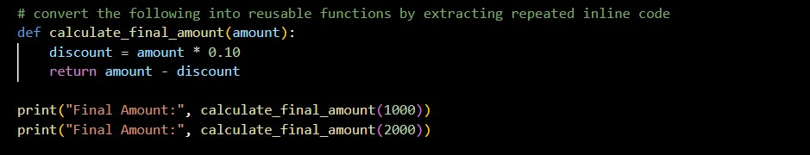
Task Description -3 (Refactoring – Improving Loop and
Conditional Performance)
- Task: Apply AI-based suggestions to enhance the performance of Python code that relies on nested loops and repeated conditional checks.
Instructions:
- Use AI to recommend more efficient data structures or logic simplifications.
- Replace inefficient constructs while preserving program behavior.
- Compare execution efficiency before and after refactoring.
Sample Code:
students = ["Anil", "Bhavya", "Charan", "Divya"] check_list = ["Charan", "Esha", "Bhavya"] for name in check_list:
exists = False for student in students: if name == student:
exists = True if exists:
print(name, "found") else:
print(name, "not found")
Expected Output:
An optimized Python program that performs faster lookups using efficient logic, along with execution performance comparison.
Prompt and Code:
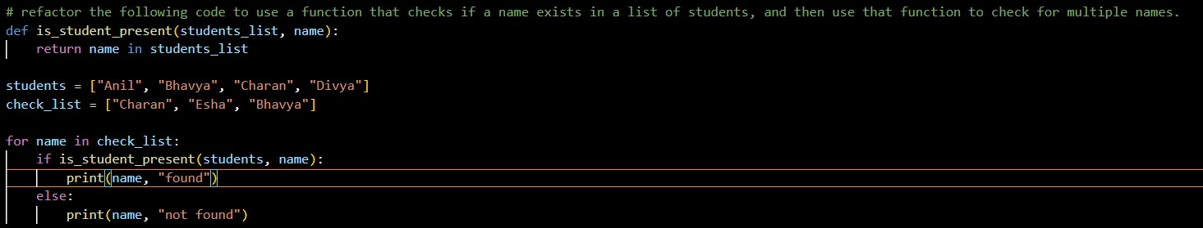
Task Description -4 (Refactoring – Replacing Hardcoded Values with Constants)
- Task: Utilize AI assistance to improve maintainability by replacing hardcoded numerical values with named constants.
Instructions:
- Detect hardcoded numeric values used directly in expressions.
- Define descriptive constants at the beginning of the program.
- Update calculations to use these constants without changing results.
Sample Code:
print("Simple Interest:", (1000 * 2 * 5) / 100) print("Simple Interest:", (2000 * 2 * 5) / 100)
Expected Output:
A revised Python program using constants such as RATE and TIME for clearer and maintainable calculations..

Prompt and Code
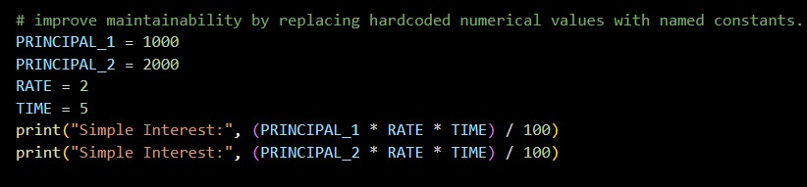

Task Description -5 (Re factoring – Enhancing Variable Naming and Code Clarity)
- Task: Apply AI tools to improve code readability by renaming unclear variables and adding meaningful comments..
Instructions:
- Replace non-descriptive variable names with meaningful identifiers.
- Add inline comments where the logic may be unclear.
- Ensure program output remains the same.
Sample Code:
x = 50 y = 30 z = x + y print(z)
Expected Output:
A Python program with clear variable names and explanatory comments
that improve readability without altering functionality.

Prompt and Code
